DCM Name | DCMBathingOutcome
DCMType: | Nursing sensitive outcome
DCMiD:
DCM Oid:
DCM Repository Id:
File name | 0000.doc
Version doc.: | 0.3
Code/Keyword: | Bathing drying, limitations, Outcome, Evaluation, Nursing process, self care deficit, Daily living ability, Nursing
Language: | English
Publication Status: | Status: | Date:
Publication Status: | Author Draft(en);  Committee Draft(en);  Organisation Draft(en);  Submitted(en);  Withdrawn  Rejected(en)  Obsolete  Approved for testing  Approved for Production Use  Superseded | 4 January 2010
Authors: | N. Rademaker, Drs. A.T.M. Goossen, Dr. W.T.F. Goossen, Results 4 Care.
Contact information : | Results4Care@cs.com
Requirement specification and Review of content
Endorsing Authority
Verification and Validity
Quality label/ Certification

Copyrights: | Licenses of source material  Not applicable  Use of the DCM  The DCM is open source, so free to use, not to be changed.  Changes in the content en codes are seen upon as a infringement of copyright and is damaging for the goal of use: realisation of semantic interoperability.  You can suggest changes at results4care@cs.com  Revision suggestions will be looked at and may lead to:  - revised DCM and results if accepted  - variations of the DCM adapted on a local situation.  This is all based upon : a “common ownership” but not a “special stewardship”.
DCM Format | UML
Additional formats | HL7 template  Archetype  Zorginformatiemodel  Plain XML

Version management
version | date | Changes | Reason of change | author
0.3 | 4-1-2010 | Edits | Review | Dr. William Goossen, Results 4 Care
0.2 | 22-12-2009 | Feedback processed and finish of mapping table (as far as possible) | Completion | Drs. A. Goossen-Baremans
0.12 | 18-06-2009 | Suggestions for changes in Code/Keyword | Review | Drs. A. Goossen-Baremans
0.11 | 17-6-2009 | First draft |  | N. Rademaker, Results 4 Care

Purpose
The determination whether the desired care outcome concerning the personal care aspect bathing and the belonging indicators, are reached.

Eviddence based
During the evaluation the nurse or care provider determines whether the desired care outcomes concerning bathing are reached. The daily bathing consists of (NOC, 2000):
- Actions that concern the conditions, like collecting the necessary items for bathing, going to the bathroom, obtaining water, controlling the temperature of the water etc.
- Actions that concern the bathing itself, like the bathing of the face, chest, back, arms, belly, legs, tail bone, wipe dry etc.
- The method of bathing like, washing at the sink, shower, taking a bath, washing on bed, etc.

Description of the variables
For the description of variables belonging to this DCM a spreadsheet in Excel is used. The filename of the spreadsheet belonging to this DCM is: DCMBathingOutcome_V_0.2.xls.

Instructions
The evaluation has the purpose to determine whether the desired results, in this case concerning bathing are reached.
The evaluation provides leads in order to adjust the nursing diagnosis and / or the nursing interventions or the way they are executed. There is a difference between end evaluation and evaluations in between. In the progress reports the in between evaluations are noted. The end evaluation can be done during a transfer (in writing) of the care for example in transmural care, displaced hospital care, home care and care in other health care facilities (CBO,1999)

Interpretation guidelines
The collected evaluation data are used to draw conclusions that determine whether the care plan is continued, adjusted or closed. If the care plan is adjusted, the nursing diagnosis is viewed and if necessary new nursing outcomes and interventions are formulated concerning the self care deficit and self care ability of the patient, after that the nursing process repeats itself.

Care process/ dependence
The outcome evaluation is a part of the care process. The outcome evaluation focuses on the review of the achievement of the desired outcomes. By evaluating the nursing care can be optimized. The following figure shows the nursing process which a patient goes through if he is admitted in a hospital.
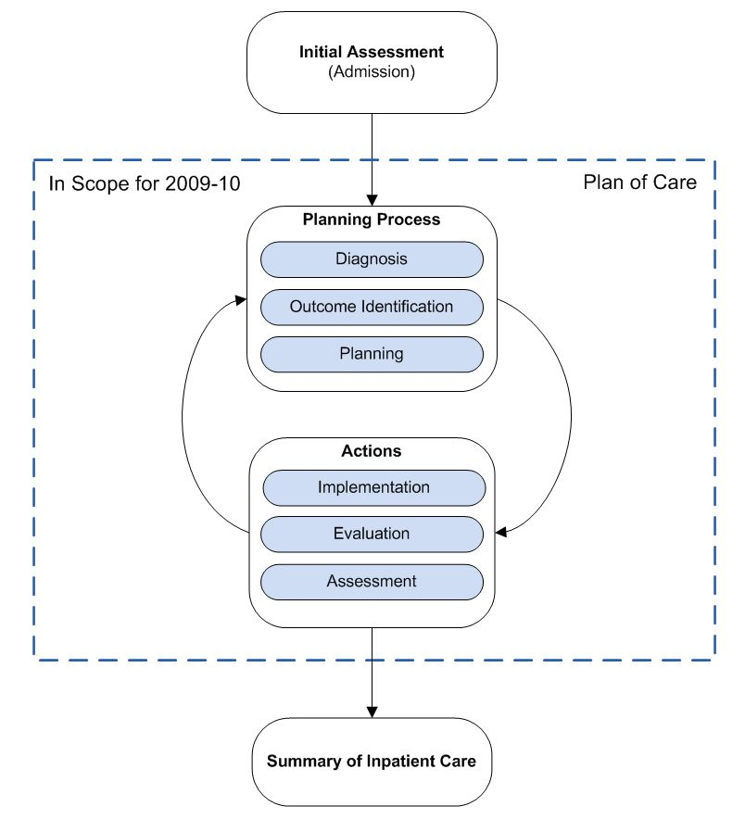
Figure 1. Nursing process (IHE, 2009).
In the nursing process the phases are related to each other in the following manner:
Nursing diagnosis:

- Self care deficit in bathing and hygiene ( Nanda/ Gordon, 2004)

Nursing interventions:

- Support in nursing care: bathing/hygiene ( NIC, 2002)

Nursing Outcome:

- Personal care: bathing (NOC, 2001)

An example of the instrument
Not applicable.

Screenshots
Not applicable.

References

Projects:
None.
Literature:
Albertsnagel, E.,Diagnosen ,resultaten en interventies. Wolters-Noordhoff, Groningen 2002.

Johnson, M., Maas, M., Verpleegkundig zorgresultaat. Elsevier, Maarssen, 2001
Kruijswijk Jansen H, Mostert H: Het verpleeg proces. De Tijdstroom, Lochem, 1994.
Stevens P.,J.,M., methodiek van het verpleegkundig handelen. Spruyt, van Mantgem en De Does, bv Leiden, 1995.
Held, M.F., Hoop, de A., Plannen van verpleegkundige Zorg. Nijgh en Versluys, Baarn, 2004.
Ormel, A.,Wiel van de , A., Plannen van zorg. Wolters- Noordhoff, Groningen. 2006
Kwaliteitsinstituut voor de Gezondheidszorg CBO, Herziening consensus verpleegkundige verslaglegging. Utrecht, 1999

Vocabulary:
SNOMED CT 2.16.840.1.113883.6.96
LOINC 2.16.840.113883.6.1
ICNP 2.16.840.1.113883.6.97 (Obtained on 22-12-2009, from http://www.oid-info.com/get/2.16.840.1.113883.6.97)
ICF 2.16.840.1.113883.6.254
NOC: 2.16.840.1.113883.6.16
NIC 2.16.840.1.113883.6.15
NANDA 2.16.840.1.113883.6.20
Omaha 2.16.840.1.113883.6.98
It is possible that people in this domain use different coding and value sets that used in this DCM. In that case, we as developers appreciate it if we were to be informed.
For the coding the use of terminologies like SNOMED CT and/or LOINC, or one of the classifications of the WHO family of classifications (for example ICD10, ICF, ICNP) has been preferred. The codes that are used are, by our opinion the best possible match between the data item (variable and/or value)and the concept/ concepts as set out in the terminology or classification. It is possible that a very rigorous analysis of one of these terminologies variations emerge that are just as good or even a better match, for instance if another perspective is chosen. There is a small chance that in the future codes for certain data items are being altered. Where we did not find a code, for now, Results 4 Care codes where made and missing concepts will be asked to SNOMED CT.

Remarks
The choice whether speaking of self care, self-help or limitations is up to the nurses or care providers themselves. Often this has to do with the vision and policy of the care facility. The consistent use of these terms throughout the care process in an individual facility is the responsibility of the facility itself.

Disclaimer
Results 4 Care B.V. gives the utmost care to the reliability and timeliness of data in this DCM, Detailed Clinical Model. Errors and inaccuracies may occur. Results 4 Care is not responsible for damages resulting from errors or inaccuracies in the information, nor for damages arising from problems caused by, or inherent in the spreading of information via the Internet, as failures or interruptions from either errors or delays in the distribution of information or services by Results 4 Care, by means of the website repository or by e-mail, or otherwise electronically.
Results 4 care does not accept responsibility for possible damage suffered as a result of the use of data, advise or ideas provided by way of this DCM. Results 4 Care does not accept responsibility for the content of information in this DCM to which or from which using a hyperlink or otherwise, is referred.
In case of contradictions in the mentioned DCM documents and files the priority of the relevant documents is stated by the most recent and highest version mentioned in the revision (version management).
In case information that is included in the electronic version of this DCM is also provided in writing, in case of textual differences the written version will determine. This applies if the version description and date of both are equal. The definitive version has priority over a concept version. A revised version has priority over a previous version.

UML

